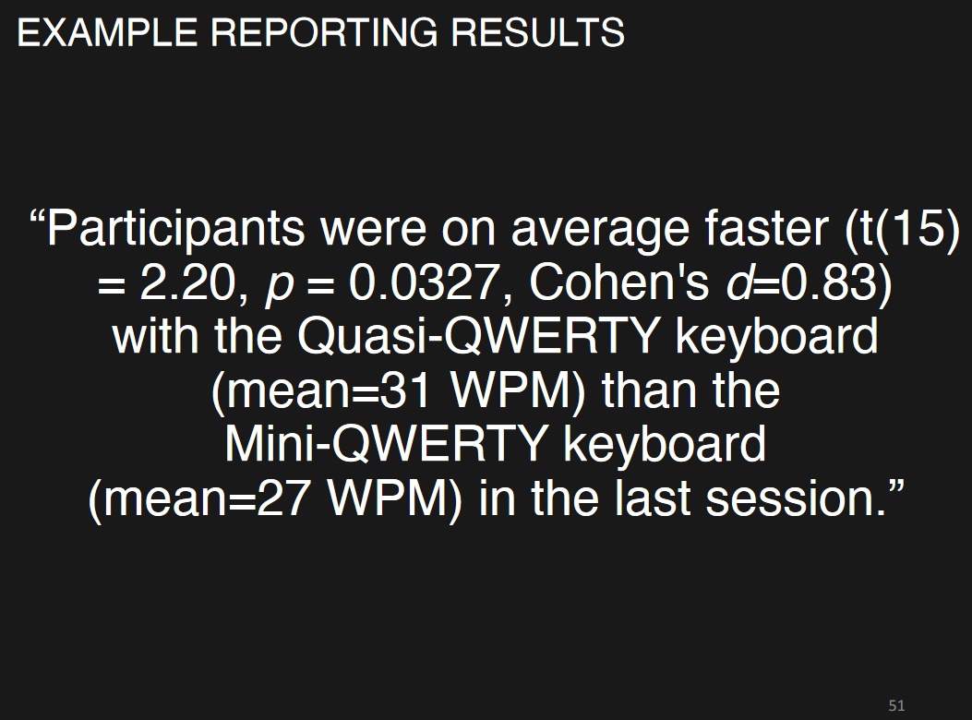

* t
* p-value

Use only session 2’s data

One-tailed paired Wilcoxon test

* Test for keyboard design x punctuation time
  + **Null Hypothesis**: There is *no difference* between the mean time to enter punctuation on our new keyboard and the mean time to enter punctuation on the original keyboard.
  + **Alternative Hypothesis**: The mean time to enter punctuation on our new keyboard is *faster than* the mean time to enter punctuation on the original keyboard.
* Test for keyboard design x emojis time
* Test for keyboard design x numbers time

<http://www.sthda.com/english/wiki/paired-samples-wilcoxon-test-in-r>

For Every Test, draw the box plot, execute the Wilcoxon test, and calculate the p value,Finally draw conclusions.

Method: Wilcoxon Single Rank Test

Since we couldn’t infer that the time completion follows a normal distribution, we used the Wilcoxon test instead.

People type punctuation the same or slower with our new keyboard design compared with the traditional keyboard in one-handed typing

For Task 1: Test the revised punctuation keyboard

Null Hypothesis: People type punctuation the same or slower with our new keyboard design compared with the traditional keyboard in one-handed typing

Alternative Hypothesis: People can type punctuation faster with our new keyboard design compared with the traditional keyboard in one-handed typing

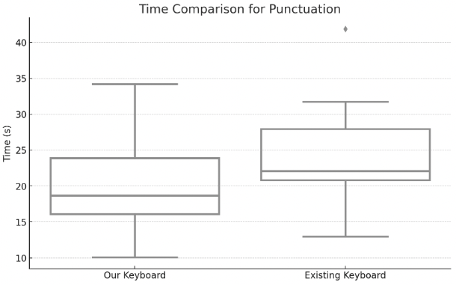

P-value: 0.0056

For the Punctuation Task, the p-value is 0.0056, which is less than the typical alpha level of 0.05. This suggests that there is a statistically significant difference in typing speed between the two keyboard designs for punctuation, favoring "Our Keyboard Design". Therefore, we reject the null hypothesis for the punctuation task.

For Task 2: Test the revised punctuation keyboard

Null Hypothesis: People type emoji the same or slower with our new keyboard design compared with the traditional keyboard in one-handed typing

Alternative Hypothesis: People can type emoji faster with our new keyboard design compared with the traditional keyboard in one-handed typing

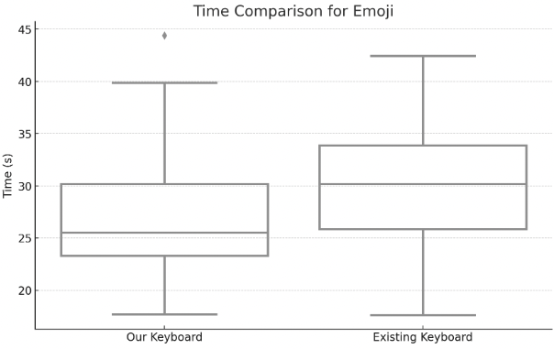

P-value: 0.0285

Emoji Task: The adjusted p-value of 0.0285 is also below the alpha level of 0.05, indicating a statistically significant difference in typing speed for emojis. This suggests that "Our Keyboard Design" is faster for typing emojis as well.

For Task 3: Test the revised number keyboard

Null Hypothesis: People type numbers the same or slower with our new keyboard design compared with the traditional keyboard in one-handed typing

Alternative Hypothesis: People can type numbers faster with our new keyboard design compared with the traditional keyboard in one-handed typing

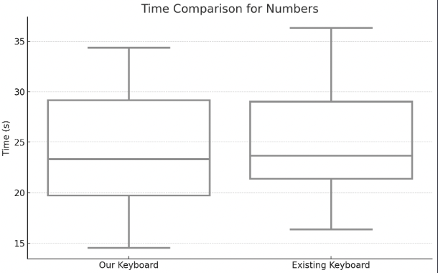

P-value: 0.2610

Numbrers Task: The p-values are 0.2610 suggesting no significant difference in typing speed for numbers between the two designs. We fail to reject the null hypothesis for these tasks.